MLP Classifier Assignment
Training Classifier using MLP (Neural Network)
Neural Network Assignment | Software Engineering Student

Aim and Task Overview
Aim: Learn the basic steps of creating and training neural networks
Task: Train a classifier for the selected dataset using a Neural Network approach.
Steps include:
• Dataset selection (Ecoli)
• Build a Multilayer Perceptron (MLP)
• Data preparation & normalization
• Training & evaluation
• Hyperparameter tuning
• Saving weights and reporting metrics

Dataset Overview
Dataset: Ecoli Dataset
• Total samples: 336
• Features: 7 (after dropping ID column)
• Classes: 8 (e.g., im, cp, pp, etc.)
• Source: UCI Machine Learning Repository
• Labels encoded using LabelEncoder from scikit-learn

MLP Model Architecture
• Input layer: 7 neurons (one for each feature)
• Hidden layer: 64 neurons with ReLU activation
• Output layer: 8 neurons (for 8 classes)
• Loss Function: CrossEntropyLoss
• Optimizer: Adam
• Device: CPU (or CUDA if available)

Training Hyperparameters
• Epochs: 500
• Batch size: 22
• Learning rate: 0.001
• Split: 80% training, 20% testing
• Optimizer: Adam
• Loss: Cross Entropy

Training Loss Over Epochs

Model Performance Metrics
• Accuracy: 88.24%
• Precision (per class): [0.96875, 0.8333, 0.5, 1.0, 0.9286]
• Recall (per class): [0.96875, 0.7143, 0.6667, 1.0, 0.9286]
• F1-score: [0.96875, 0.7692, 0.5714, 1.0, 0.9286]
• Confusion Matrix shown on next slide

Confusion Matrix
Python Code Summary
• Used libraries: NumPy, Pandas, Scikit-learn, PyTorch
• Data normalized using StandardScaler
• Labels encoded using LabelEncoder
• Model: 2-layer MLP with ReLU and Softmax (via CrossEntropyLoss)
• Loss and accuracy plotted
• Model weights saved using torch.save
Conclusion
• Successfully implemented MLP for multi-class classification
• Achieved good accuracy with balanced precision/recall
• Training loss shows good convergence
• Model generalizes well with test data
• Next steps: experiment with deeper networks, regularization, and different learning rates

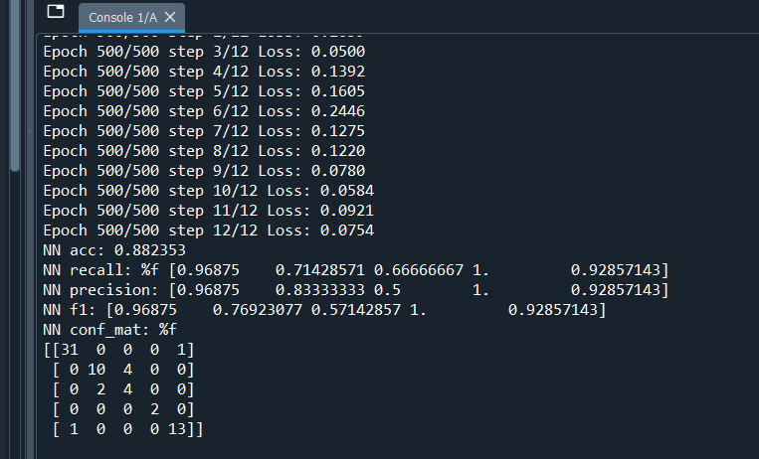
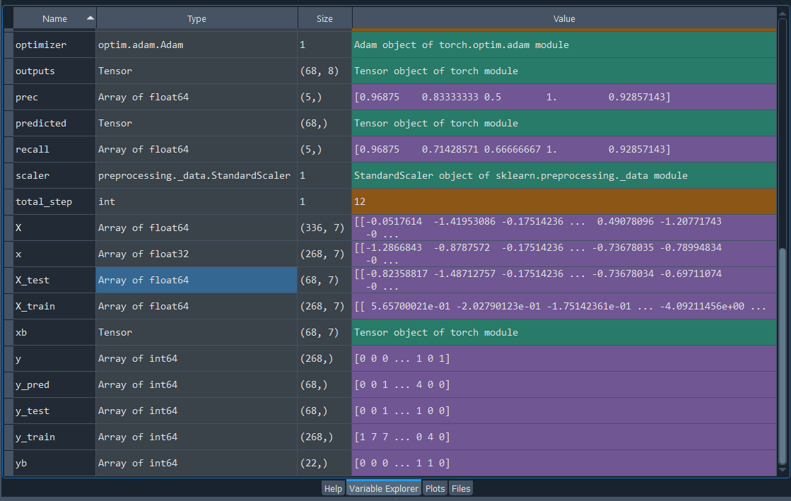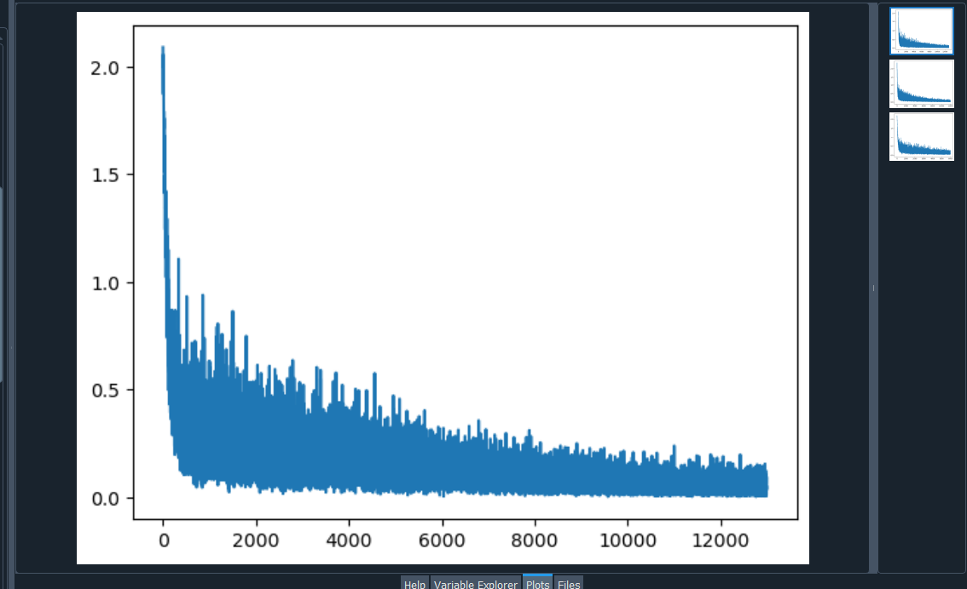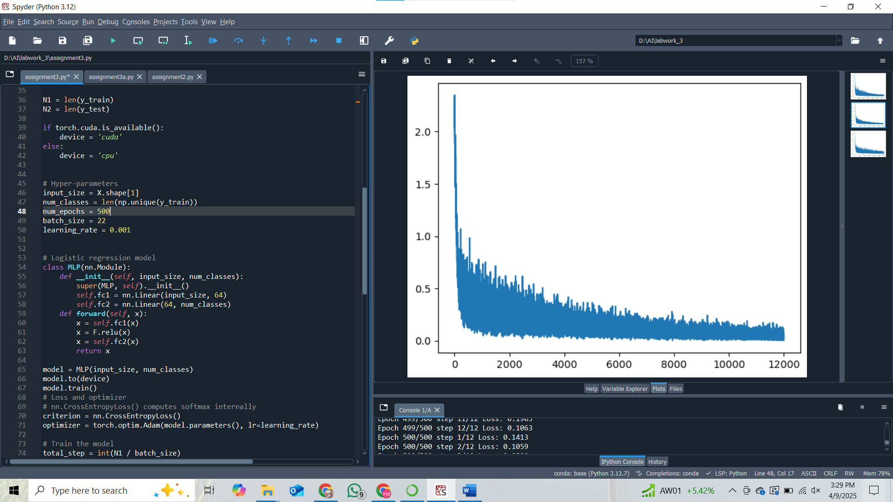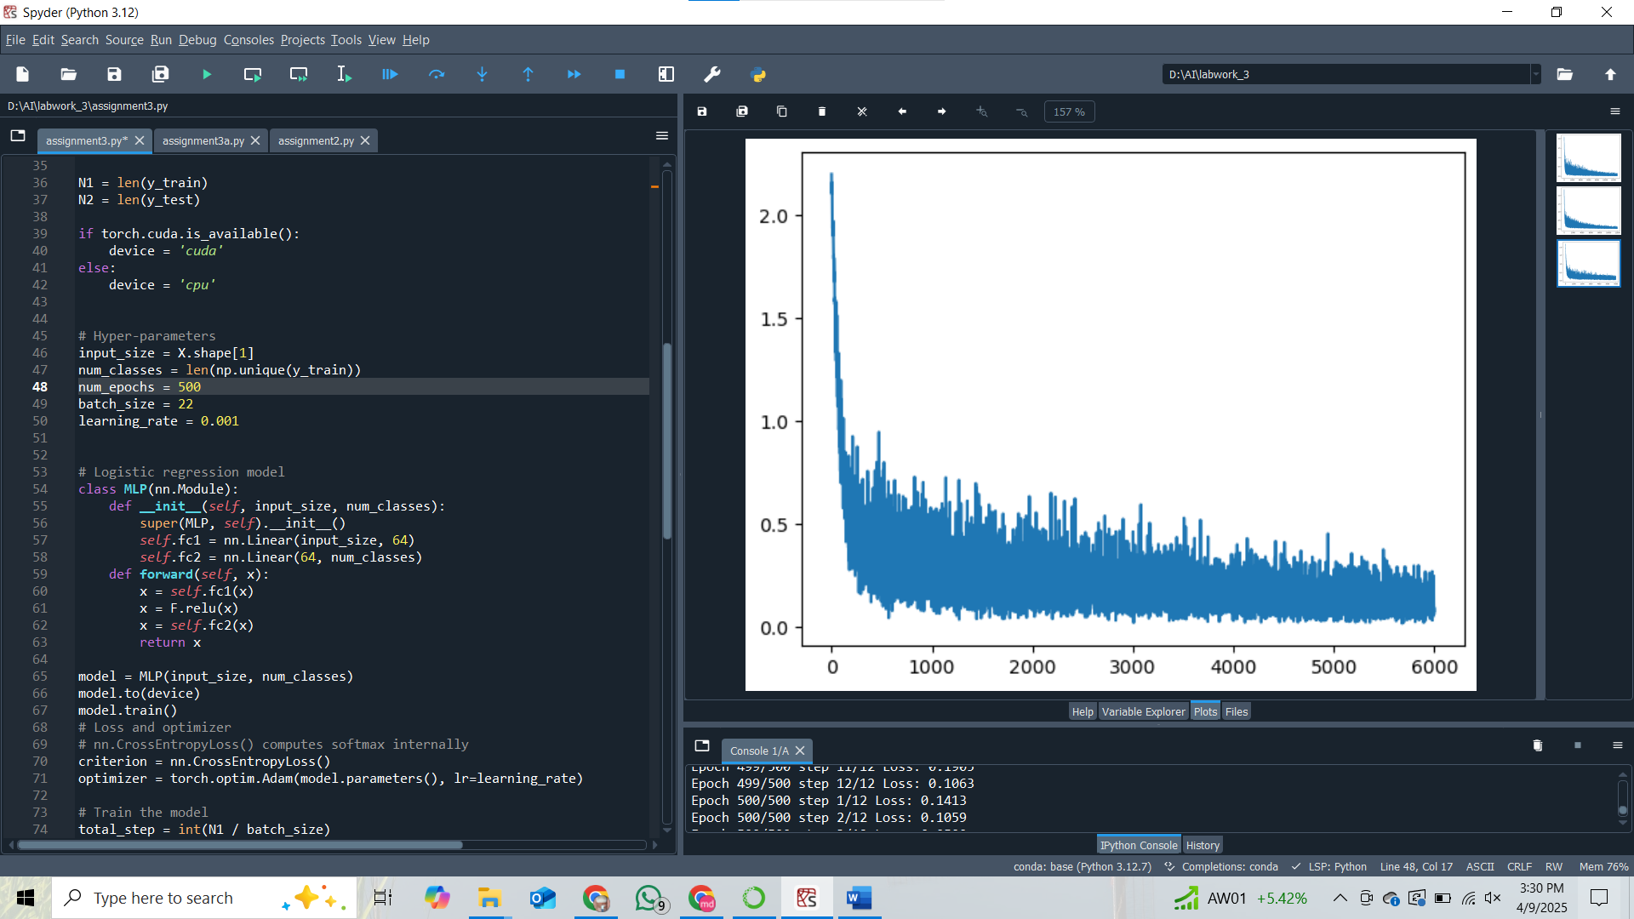import numpy as np

from sklearn.datasets import load_iris
from sklearn import metrics
from sklearn import model_selection
from sklearn.utils import shuffle
import sklearn.preprocessing
import torch
import torch.nn as nn
import torch.nn.functional as F
import matplotlib.pyplot as plt
import pandas as pd
from sklearn.preprocessing import LabelEncoder

# Load dataset
df = pd.read_csv('D:/AI/labwork_3/39_Ecoli/ecoli.data', sep=r'\s+', header=None)

X = df.iloc[:, 1:-1] # Skips the first column (ID) and selects features
y = df.iloc[:, -1] # Last column as target

scaler = sklearn.preprocessing.StandardScaler()
X = scaler.fit_transform(X)

X_train, X_test, y_train, y_test = model_selection.train_test_split(X, y,
test_size=0.2, random_state=1)

# Convert string labels to integers
label_encoder = LabelEncoder()
y_train = label_encoder.fit_transform(y_train)
y_test = label_encoder.transform(y_test)

y_train = np.array(y_train, dtype=np.int64)
y_test = np.array(y_test, dtype=np.int64)

N1 = len(y_train)
N2 = len(y_test)

if torch.cuda.is_available():
device = 'cuda'
else:
device = 'cpu'

# Hyper-parameters
input_size = X.shape[1]
num_classes = len(np.unique(y_train))
num_epochs = 500
batch_size = 22
learning_rate = 0.001

# Logistic regression model
class MLP(nn.Module):
def __init__(self, input_size, num_classes):
super(MLP, self).__init__()
self.fc1 = nn.Linear(input_size, 64)
self.fc2 = nn.Linear(64, num_classes)
def forward(self, x):
x = self.fc1(x)
x = F.relu(x)
x = self.fc2(x)
return x

model = MLP(input_size, num_classes)
model.to(device)
model.train()
# Loss and optimizer
# nn.CrossEntropyLoss() computes softmax internally
criterion = nn.CrossEntropyLoss()
optimizer = torch.optim.Adam(model.parameters(), lr=learning_rate)

# Train the model
total_step = int(N1 / batch_size)
losses = []
for epoch in range(num_epochs):
x, y = shuffle(X_train, y_train)
x = np.array(x, dtype=np.float32)

for i in range(total_step):
xb = x[i*batch_size : (i+1)*batch_size]
xb = torch.from_numpy(xb).to(device)
yb = y[i*batch_size : (i+1)*batch_size]
labels = torch.from_numpy(yb).to(device)
# Forward pass
outputs = model(xb)
loss = criterion(outputs, labels)

# Backward and optimize
optimizer.zero_grad()
loss.backward()
optimizer.step()
losses.append(loss.item())
print ('Epoch %d/%d step %d/%d Loss: %.4f' %(epoch+1, num_epochs, i+1, total_step, loss.item()) )

# Test the model
# In test phase, we don't need to compute gradients (for memory efficiency)

plt.figure()
plt.plot(losses)
plt.show()

model.eval()
with torch.no_grad():
xb = np.array(X_test, dtype=np.float32)
xb = torch.from_numpy(xb).to(device)
outputs = model(xb)
_, predicted = torch.max(outputs.data, 1)
y_pred = predicted.cpu().numpy()

# Save the model checkpoint
torch.save(model.state_dict(), 'model.ckpt')

acc = metrics.accuracy_score(y_test, y_pred)
print("NN acc: %f" %acc )

recall = metrics.recall_score(y_test, y_pred, average=None)
print("NN recall: %f", recall )

prec = metrics.precision_score(y_test, y_pred, average=None)
print("NN precision:", prec )

f1 = metrics.f1_score(y_test, y_pred, average=None)
print("NN f1:", f1 )

conf_mat = metrics.confusion_matrix(y_test, y_pred)
print("NN conf_mat: %f")
print(conf_mat)

